**Medical Inventory Management Project – Agile Scrum Documentation**

**1. Introduction**

In today’s fast-paced environment, businesses require systems that are adaptable, efficient, and responsive to change. This documentation outlines the Agile Scrum framework for developing and continuously enhancing the Medical Inventory Management system. This GUI-based application, which leverages Python and Excel integration, is designed to manage medicine inventory, process sales and refills, and automatically flag low-stock items. By employing Agile and Scrum principles, the team can respond to evolving customer needs and deliver incremental value over time.

**Theory in Practice:**

Agile methodologies emphasize iterative development and constant feedback, enabling teams to quickly adjust to new requirements. Scrum, as one of the most popular Agile frameworks, focuses on time-boxed sprints, clear role definitions, and regular communication, ensuring that both the development process and the product itself evolve to meet stakeholder needs.

**2. Project Overview**

**2.1. Project Objectives**

* **Core Functionality:**
* Develop a GUI-based application that interfaces with an Excel inventory database.
* Process sales and stock refills, with real-time updates to the Excel file.
* Implement an automated alert system to flag items falling below the reorder level.
* **Continuous Enhancement:**
* Incrementally add features based on feedback from end users and stakeholders.
* Enhance usability, performance, and reporting capabilities as the system evolves.

**Theory in Practice:**

The objective of any software project is not only to deliver a functional product but also to create a system that can grow and adapt over time. Agile theory posits that by delivering in small, incremental pieces, the team can mitigate risks and ensure the product remains aligned with business goals.

**2.2. Target Users**

* Hospital staff and pharmacists who require a simple, reliable interface.
* Inventory managers responsible for tracking and maintaining medicine stocks.
* Stakeholders and clients who demand continuous visibility into the system’s progress.

**Theory in Practice:**

User-centered design is a cornerstone of Agile methodology. By involving target users early and often through sprint reviews and feedback sessions, the team ensures that the final product is not only technically sound but also truly meets user needs.

**3. Team Structure and Roles**

The success of any Agile project lies in the strength and clarity of its team. For this project, the team is composed of six core members, with an extended role for the client as an active stakeholder.

**1. Business Analyst / Scrum Master (Team Lead):**

* **Responsibilities:**
* Define and prioritize the product backlog.
* Facilitate Scrum ceremonies, ensuring clear communication and removing blockers.
* Act as the primary liaison between the development team and the client.
* **Theoretical Background:**

The role of the Scrum Master is central to Agile theory. The Scrum Master is responsible for ensuring that Agile practices are followed and that the team functions optimally. This role is critical in fostering a culture of continuous improvement and learning.

**2. Python Developers (2):**

* **Responsibilities:**
* Develop the Python codebase for the GUI and backend logic.
* Integrate new features into the existing system based on sprint goals.
* Maintain high coding standards and ensure seamless Excel integration.
* **Theoretical Background:**

Agile teams are cross-functional, meaning that developers must be versatile and able to collaborate closely with testers and analysts. This encourages knowledge sharing and reduces dependencies.

**3. Tester:**

* **Responsibilities:**
* Develop and execute test cases for all sprint deliverables.
* Conduct regression testing to ensure that new features do not compromise existing functionality.
* Work with developers to promptly address issues.
* **Theoretical Background:**

Continuous testing is a key principle in Agile, emphasizing early defect detection and ensuring that quality is built into the product from the start. This approach is aligned with the Agile principle of “working software over comprehensive documentation.”

**4. Data Analyst:**

* **Responsibilities:**
* Analyze inventory data for trends and performance reporting.
* Validate the accuracy and consistency of the Excel data.
* Support the team in developing data visualizations and advanced reporting features.
* **Theoretical Background:**

Data-driven decision-making is fundamental in Agile. The data analyst ensures that the team makes informed decisions, thereby reducing uncertainty and improving overall product quality.

**5. Client (Stakeholder):**

* **Responsibilities:**
* Provide regular feedback and validate sprint deliverables.
* Actively participate in sprint reviews and backlog refinement.
* Ensure that the product meets evolving business requirements.
* **Theoretical Background:**

The Agile Manifesto values customer collaboration over contract negotiation. The client’s active involvement ensures that the final product is closely aligned with business goals and user needs.

**4. Agile Scrum Framework Overview**

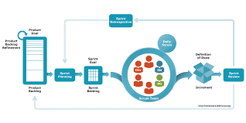

**4.1. Sprint Duration and Overall Timeline**

* **Sprint Duration:** Each sprint lasts 3 weeks.
* **Initial Plan:** 12 sprints over an initial 4-month period.
* **Flexibility:** The project timeline is adaptable, with the possibility of extending sprints based on customer needs.

**Theory in Practice:**

Time-boxing is a key Agile principle. By setting a fixed duration for sprints, teams are encouraged to focus on delivering a minimum viable product (MVP) and iterating based on feedback, rather than trying to perfect everything in one go.

**4.2. Scrum Ceremonies**

* **Sprint Planning:**
* The team reviews the product backlog, selects items for the sprint, and defines the sprint goal.
* Tasks are broken down into manageable pieces, and clear acceptance criteria are established.
* **Daily Stand-ups:**
* Short meetings (approximately 15 minutes) to share progress, plans, and obstacles.
* **Sprint Review:**
* At the end of the sprint, the team demonstrates the completed work to the client and stakeholders.
* Feedback is gathered for continuous improvement.
* **Sprint Retrospective:**
* The team reflects on the sprint to discuss what went well, what didn’t, and how processes can be improved.

**Theory in Practice:**

Scrum ceremonies are designed to foster transparency, inspection, and adaptation—the three pillars of empiricism in Agile. Regular ceremonies ensure that the team remains focused, aligned, and continuously improving.

**4.3. Product Backlog and Sprint Backlog**

* **Product Backlog:**
* A prioritized list of all features, enhancements, and bug fixes maintained by the Scrum Master and Business Analyst.
* **Sprint Backlog:**
* A subset of the product backlog selected for implementation in the current sprint.
* Detailed tasks and acceptance criteria are defined for each sprint backlog item.

**Theory in Practice:**

The product backlog is a dynamic, evolving document that reflects the current state of the project and future goals. It is continually refined (a process known as backlog grooming) to ensure that the team is always working on the highest-priority items.

**5. Detailed Sprint Framework (Each Sprint = 3 Weeks)**

**5.1) Sprint 0: Initial Planning and Setup (Week 1)**

* **Objective:**

Establish the project foundation by gathering requirements, defining the product backlog, and setting up initial infrastructure.

* **Key Activities:**
* **Requirements Gathering & User Stories:**
* Define critical functionalities such as Sell Medicine, Refill Stock, Low Stock Alert, and Data Reporting.
* Work with the client to prioritize user stories.
* **Team Formation & Role Assignment:**
* Finalize team roles (Business Analyst/Scrum Master, Python Developers, Tester, Data Analyst, Client).
* **Technical Setup:**
* Define the system architecture, including data storage (Excel on local drive).
* Set up initial development environment and version control.
* **Backlog Creation:**
* Create a detailed product backlog in Excel.
* **Scrum Framework Introduction:**
* Schedule Scrum ceremonies (Sprint Planning, Daily Stand-ups, Sprint Reviews, Retrospectives).
* **Deliverables:**
* Approved product backlog.
* Initial system architecture documentation.
* Defined roles and Scrum process outline.

**Theory in Practice:**

Sprint 0 lays the groundwork by aligning the team on goals, establishing a communication structure, and creating a roadmap. It minimizes risk by clarifying requirements and setting up the technical environment.

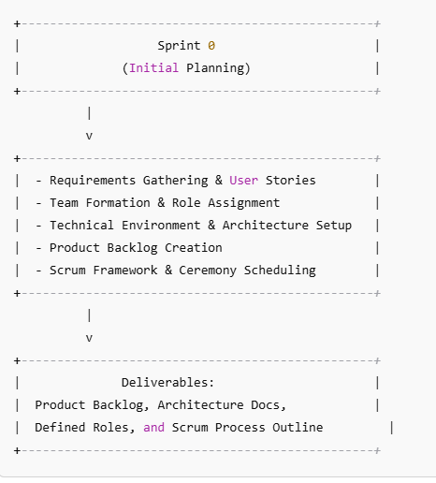

**5.2) Sprint 1: Core “Sell Medicine” Functionality (Weeks 2-4)**

* **Objective:**

Develop and test the “Sell Medicine” feature to handle sales transactions and update inventory.

* **Key Activities:**
* **Sprint Planning:**
* Define the sprint goal: implement “Sell Medicine” functionality.
* Break down tasks: create GUI components, integrate Excel update logic, set up logging.
* **Development:**
* Python Developers code the sale process.
* Integrate error handling and logging for each transaction.
* **Testing:**
* Tester develops test cases for sale scenarios.
* Validate that inventory quantities update correctly.
* **Daily Stand-ups:**
* Share progress and address any blockers.
* **Sprint Review:**
* Demonstrate the “Sell Medicine” functionality.
* Collect feedback from the client.
* **Retrospective:**
* Identify areas for improvement in the process.
* **Deliverables:**
* Functional “Sell Medicine” feature.
* Transaction log records.
* Initial feedback from the client.
* **Theory in Practice:**

Delivering a single, well-defined feature allows the team to focus on quality and user acceptance. This sprint sets the precedent for how future transactions will be managed and validated.

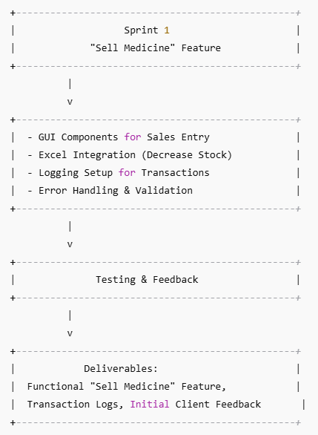

**5.3) Sprint 2: Core “Refill Stock” Functionality (Weeks 5-7)**

* **Objective:**

Implement the “Refill Stock” feature to allow inventory updates and addition of new medicines.

* **Key Activities:**
* **Sprint Planning:**
* Define tasks: develop refill logic, integrate with GUI, handle new medicine entries.
* **Development:**
* Python Developers code the refill functionality.
* Ensure seamless integration with the existing “Sell Medicine” feature.
* **Testing:**
* Tester verifies that stock is updated correctly for existing medicines.
* Test scenarios for adding new medicines to the inventory.
* **Daily Stand-ups, Review, and Retrospective:**
* Regular updates and feedback sessions, similar to Sprint 1.
* **Deliverables:**
* Working “Refill Stock” feature.
* Updated Excel file reflecting stock refills.
* Test case documentation and feedback.
* **Theory in Practice:**

This sprint builds on Sprint 1 by adding complementary functionality. It reinforces the iterative approach by expanding the system’s capabilities based on user needs.

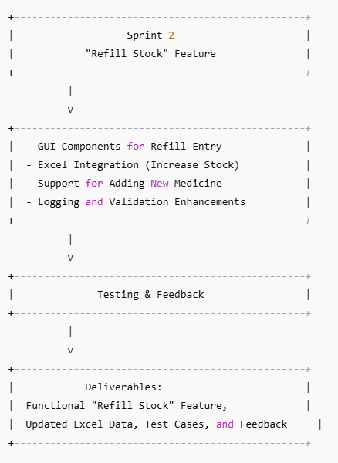

**5.4) Sprint 3: Low Stock Alert Integration (Weeks 8-10)**

* **Objective:**

Integrate the dynamic low stock alert mechanism that automatically updates the “Alert” column in the Excel file based on the reorder level.

* **Key Activities:**
* **Sprint Planning:**
* Set sprint goal: implement and test low stock alerts.
* Define tasks: modify Excel update logic, integrate alert checks, adjust GUI display.
* **Development:**
* Developers enhance existing code to compare “Quantity in Stock” with “Reorder Level.”
* Update Excel file with a dedicated “Alert” column.
* **Testing:**
* Tester validates that the alert triggers correctly when stock falls below the reorder level.
* **Daily Stand-ups, Review, and Retrospective:**
* Continue with established Scrum ceremonies.
* **Deliverables:**
* Fully integrated low stock alert functionality.
* Excel file reflecting alert updates.
* User feedback on alert visibility and accuracy.
* **Theory in Practice:**

The low stock alert is a critical feedback mechanism that informs stakeholders about inventory status. This sprint demonstrates Agile’s ability to quickly add value and improve operational efficiency.

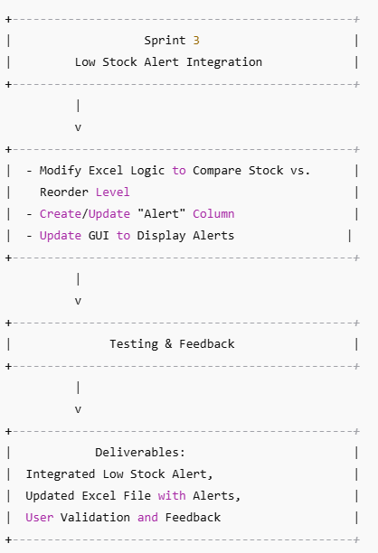

**5.5) Sprint 4: GUI Enhancements and Usability Improvements (Weeks 11-13)**

* **Objective:**

Enhance the user interface for better usability and improved data entry experience.

* **Key Activities:**
* **Sprint Planning:**
* Define UI/UX improvements based on user feedback.
* Tasks include layout redesign, improved input validation, and visual feedback.
* **Development:**
* Python Developers refine the Tkinter GUI.
* Integrate better error messages and real-time feedback mechanisms.
* **Testing:**
* Tester performs usability tests and collects user experience feedback.
* **Daily Stand-ups, Review, and Retrospective:**
* Standard Scrum activities with a focus on design improvements.
* **Deliverables:**
* Improved GUI with enhanced usability.
* User feedback reports and validation.
* Updated design documentation.

**Theory in Practice:**

A well-designed user interface is crucial for adoption and ease of use. This sprint applies iterative design principles to ensure the application is both functional and user-friendly.

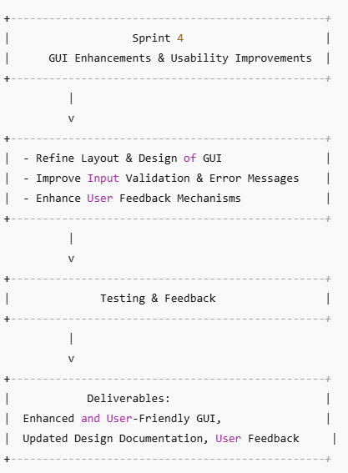

**5.6) Sprint 5: Initial Reporting and Data Visualization (Weeks 14-16)**

* **Objective:**

Develop reporting functionality to generate insights such as inventory status, sales history, and low stock trends.

* **Key Activities:**
* **Sprint Planning:**
* Define reporting requirements and select key metrics.
* Tasks include developing scripts for generating reports and designing simple data visualizations.
* **Development:**
* Python Developers code the reporting module.
* Data Analyst works on data validation and visualization integration.
* **Testing:**
* Tester validates accuracy of reports and consistency of data.
* **Daily Stand-ups, Review, and Retrospective:**
* Focus on data accuracy and user interpretation of reports.
* **Deliverables:**
* Working reporting functionality with initial dashboards.
* Documentation of key metrics and insights.
* Feedback from stakeholders on report usability.

**Theory in Practice:**

Data visualization transforms raw data into actionable insights. This sprint underscores the importance of data-driven decision-making in modern software solutions.

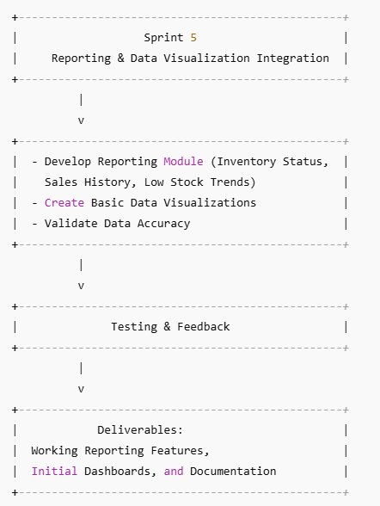

**5.7) Sprint 6: Excel Integration Optimization and Automated Backup (Weeks 17-19)**

* **Objective:**

Optimize Excel integration for faster performance and implement an automated backup mechanism.

* **Key Activities:**
* **Sprint Planning:**
* Identify performance bottlenecks in Excel interactions.
* Plan tasks to optimize file I/O operations and establish backup procedures.
* **Development:**
* Python Developers refactor code for efficiency.
* Implement automated backup scripts that store copies of the Excel file on a secure local folder.
* **Testing:**
* Tester benchmarks performance improvements and verifies backup functionality.
* **Daily Stand-ups, Review, and Retrospective:**
* Focus on performance metrics and risk mitigation.
* **Deliverables:**
* Optimized Excel integration with improved performance.
* Automated backup functionality with scheduled tasks.
* Performance test reports and backup logs.

**Theory in Practice:**

Performance optimization is crucial for user satisfaction. By automating backups, the system also ensures data safety and resilience, aligning with best practices in risk management.

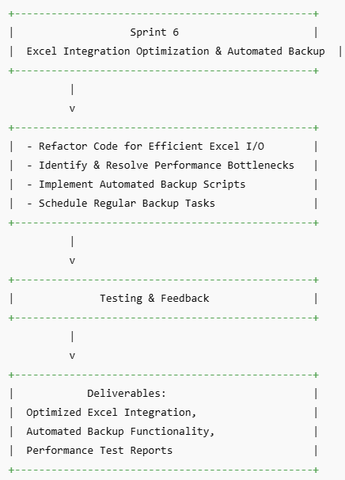

**5.8) Sprint 7-12: Incremental Improvements and Feature Additions (Weeks 20-36)**

* **Objective:**

Continue iteratively improving the system by adding advanced features, refining existing functionality, and incorporating client feedback.

* **Key Activities (across these sprints):**
* **Feature Enhancements:**
* Add advanced search and filtering for inventory data.
* Integrate additional data visualizations (charts, graphs) for deeper insights.
* Enhance reporting capabilities to include more detailed trends and forecasts.
* **Usability and Performance:**
* Refine the GUI based on further usability testing.
* Optimize system performance and code quality.
* **Customer Feedback Integration:**
* Regularly incorporate feedback from sprint reviews.
* Prioritize backlog items based on evolving customer needs.
* **Documentation and Training:**
* Update user guides and technical documentation.
* Prepare training sessions for pharmacy staff.
* **Sprint Breakdown:**

**Sprint 7:** Implement advanced search and filtering features.

**Sprint 8:** Enhance data visualization and reporting dashboards.

**Sprint 9:** Improve integration with local pharmacy systems (e.g., import/export of data).

**Sprint 10:** Further GUI refinements and additional error handling.

**Sprint 11:** Finalize performance optimizations and document system usage.

**Sprint 12:** Final customer review, prepare for launch, and conduct training sessions.

* **Deliverables:**
* A robust, feature-rich Medical Inventory Management system.
* Comprehensive documentation and training materials.
* Final performance and usability benchmarks.
* A release-ready product that can be scaled or extended based on future requirements.

**Theory in Practice:**

By delivering incremental improvements over multiple sprints, the team embraces the Agile philosophy of continuous delivery. This phase ensures that the system evolves in response to real user feedback and remains adaptable to changing business needs.

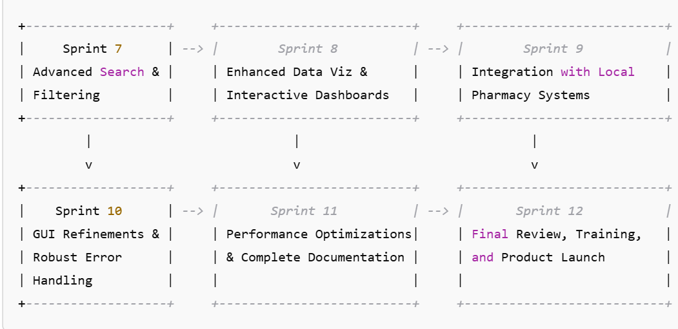

**6. Data Storage Architecture**

**6.1. Data Storage Overview**

Every pharmacy typically maintains its own information system where critical data is stored on local drives or secure networked servers. In this project, we propose the following data storage strategy:

* **Local Data Storage:**
* The primary data for the Medical Inventory Management system (e.g., inventory records, transaction logs, and low-stock alerts) will be stored in an Excel file on the pharmacy’s local drive. This file acts as the single source of truth for inventory data.
* Each pharmacy can maintain its own copy of the Excel file, ensuring that data is stored on-premise, meeting security and compliance requirements.
* **Data Integration and Backup:**
* The application (built using Python and Tkinter) will update and retrieve data directly from this Excel file.
* To prevent data loss, periodic backups can be scheduled either manually or via automated scripts, which store backup files on a secure folder within the pharmacy’s drive.
* Optionally, the system can be extended to support integration with a centralized database (e.g., SQL Server or SQLite) if the pharmacy opts for more robust data management in the future.
* **Data Security:**
* Access to the local drive is managed by the pharmacy’s IT policies.
* The application enforces data validation and error handling to maintain data integrity.
* Sensitive data (if any) will be encrypted or secured according to best practices.

**Theory in Practice:**

This approach leverages the existing IT infrastructure of each pharmacy, ensuring that data remains secure and accessible while allowing the system to be updated easily through a familiar Excel interface. It also supports scalability—if future requirements dictate, the local Excel system can transition to a more robust database solution without disrupting the application’s core functionality.

**6.9) Conclusion:**

This detailed sprint framework, combined with a clear data storage architecture, provides a robust roadmap for the Medical Inventory Management project. Each sprint is structured to deliver incremental value while allowing for continuous improvement based on client and user feedback. The outlined data storage approach ensures that each pharmacy can securely and efficiently manage its inventory data using their existing local infrastructure, with the option to scale or enhance as needed.

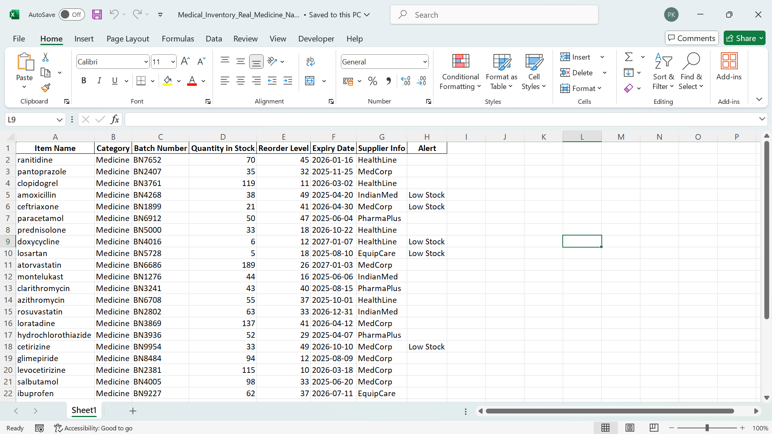

**7. Roles and Responsibilities During Each Sprint**

**7.1. Business Analyst / Scrum Master**

* **Before the Sprint:**
* Refine the product backlog by collaborating with the client and team.
* Prepare sprint planning sessions and define clear sprint goals.
* **During the Sprint:**
* Facilitate daily stand-ups, remove blockers, and ensure smooth communication.
* Monitor progress and adjust tasks as needed based on feedback.
* **After the Sprint:**
* Lead the sprint retrospective, capture lessons learned, and update the backlog.

**Theory in Practice:**

The Scrum Master is not just a facilitator but also a servant leader who empowers the team. This role is fundamental in promoting Agile values and ensuring that the team remains focused on delivering value.

**7.2. Python Developers**

* **Before the Sprint:**
* Review the sprint backlog and prepare technical tasks.
* **During the Sprint:**
* Develop new features, ensuring adherence to coding standards.
* Collaborate with the Tester to integrate and validate new functionality.
* **After the Sprint:**
* Participate in reviews and retrospectives, providing insights on technical improvements.

**Theory in Practice:**

Agile emphasizes collaboration and continuous integration. Developers work closely with other team members to ensure that every piece of code is integrated seamlessly into the overall system.

**7.3. Tester**

**Before the Sprint:**

* Assist in defining acceptance criteria and prepare test plans.

**During the Sprint:**

* Develop, execute, and document test cases.
* Report defects and work with developers to resolve them promptly.

**After the Sprint:**

* Validate fixes during the sprint review and provide feedback during retrospectives.

**Theory in Practice:**

* Quality assurance in Agile is continuous. Testers ensure that each increment of the product is of high quality, reducing the likelihood of major issues later in the development cycle.

**7.4. Data Analyst**

**Before the Sprint**:

* Collaborate in defining data requirements and performance metrics.

**During the Sprint:**

* Validate inventory data, analyze trends, and prepare initial reporting features.

**After the Sprint:**

* Provide insights and recommendations based on data analysis for future sprints.

**Theory in Practice**:

* Data analysts enable the team to make informed, evidence-based decisions. Their work is crucial for maintaining the integrity of the inventory system and ensuring that strategic decisions are backed by reliable data.

**7.5. Client (Stakeholder)**

**Throughout the Sprint:**

* Provide ongoing feedback during sprint reviews.
* Validate requirements and offer suggestions for improvements.
* Participate in backlog refinement to ensure that priorities remain aligned with business objectives.

**Theory in Practice:**

* Customer collaboration is at the heart of Agile. Regular interaction with the client ensures that the product continuously evolves to meet real-world business needs and user expectations.

**8. Quality Assurance and Continuous Improvement**

**8.1. Quality Assurance**

* **Testing Methodologies:**
* A combination of automated and manual testing is employed each sprint.
* Regression testing ensures that new features do not impact existing functionality.
* **Peer Reviews:**
* Code reviews and pair programming sessions help maintain high code quality.

**Theory in Practice:**

* Quality is built into the product at every stage. Agile’s focus on “working software” ensures that quality assurance is an ongoing, integral part of the development process rather than a final step.

**8.2. Continuous Improvement**

* **Retrospectives:**
* After each sprint, the team reflects on what went well and what could be improved.
* Actionable insights are recorded and implemented in subsequent sprints.
* **Backlog Refinement:**
* The product backlog is continually updated to reflect changing priorities and customer feedback.

**Theory in Practice:**

The principle of continuous improvement, or Kaizen, is central to Agile. By learning from each sprint, the team becomes more efficient, and the product continuously evolves to better meet user needs.

**9. Release Management and Customer Feedback**

**9.1. Incremental Releases**

* **Strategy:**
* At the end of each sprint, a potentially shippable product increment is demonstrated.
* Releases are made incrementally to allow the client to assess progress and provide timely feedback.

**Theory in Practice:**

Incremental releases help mitigate risk by ensuring that the product is always in a releasable state. This approach allows for early detection of issues and enables rapid iteration.

**9.2. Customer Feedback Loop**

* **Process:**
* Feedback from sprint reviews is documented and used to refine future product backlog items.
* Regular communication channels ensure that the client’s voice is heard and integrated into the development process.

**Theory in Practice:**

The Agile feedback loop is designed to reduce misunderstandings and ensure that the product remains aligned with user needs. This loop is critical for maintaining transparency and trust between the development team and the client.

**10. Risk Management and Flexibility**

**10.1. Identified Risks**

**Scope Creep:**

* Mitigation through strict backlog prioritization and continuous stakeholder communication.

**Technical Challenges:**

* Early technical spikes and regular code reviews help address complex issues.

**Resource Availability:**

* Cross-training and flexible sprint planning minimize the impact of resource shortages.

**Theory in Practice:**

Risk management in Agile is proactive. By identifying potential risks early, the team can take corrective actions before issues escalate, ensuring the project remains on track.

**10.2. Flexibility**

**Adaptability:**

* The Agile framework is inherently flexible, allowing the team to pivot as needed.
* Sprints may be extended or additional sprints added based on customer needs.

**Theory in Practice:**

Agile embraces change. The ability to adapt is one of the core advantages of Agile methodologies, enabling the team to respond effectively to emerging challenges and opportunities.

**11. Conclusion**

This comprehensive Agile Scrum documentation outlines the strategy, roles, processes, and theoretical foundations for the Medical Inventory Management project. By following this framework, a dedicated team—comprising a Business Analyst/Scrum Master, two Python Developers, a Tester, a Data Analyst, and an engaged Client—will deliver a robust, user-centric product through 12 sprints over an initial 4-month period. The process is designed to be iterative and flexible, ensuring that the product can evolve beyond the initial timeline as customer needs dictate.

Agile Scrum is not just a methodology—it’s a mindset that values collaboration, transparency, and continuous learning. This documentation serves as a guide to ensure that all team members understand their roles, the processes, and the underlying principles that drive the project toward success.

**Name=Pratik Kale**